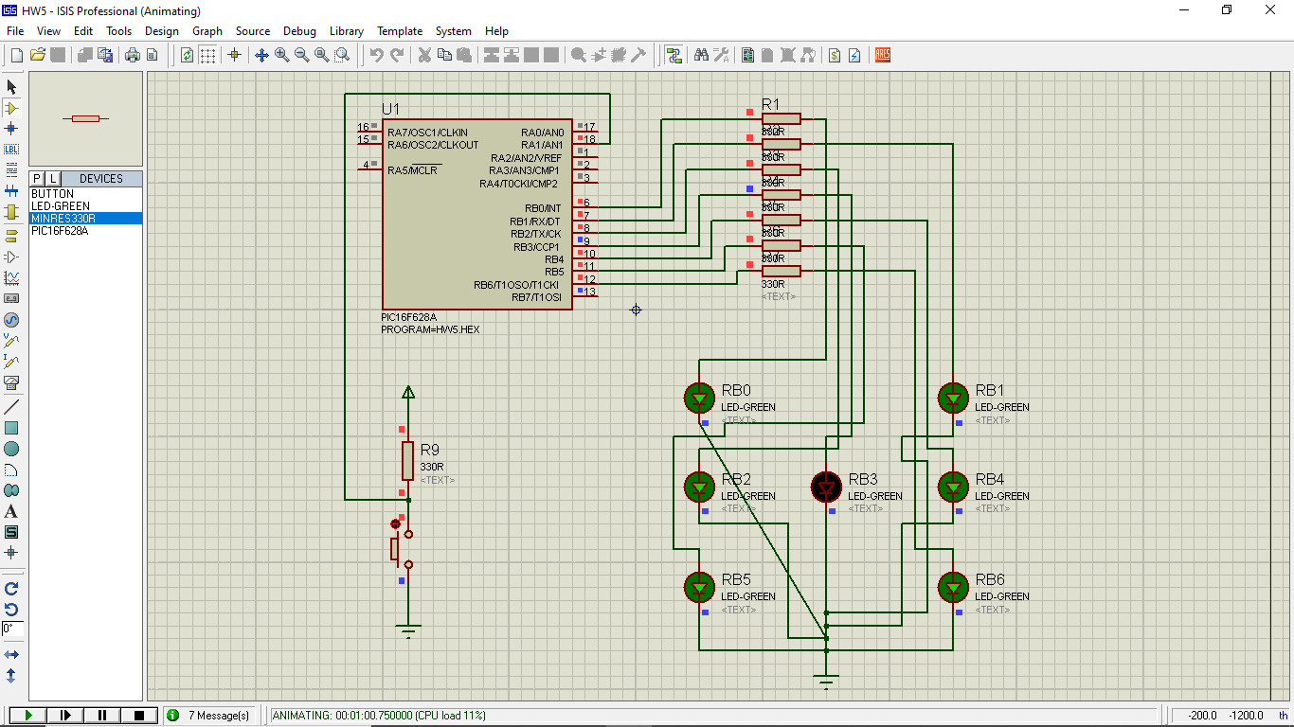

;*******************************************

;HW5 press switch random, release to show dice output.asm

;*******************************************

PROCESSOR PIC16F628

#include <P16F628.INC>

__CONFIG _CP_OFF & _MCLRE_OFF & _HS_OSC & _LVP_OFF & _WDT_OFF

**cblock** 0x20

temp

temp1

count

count0

count1

count2

**endc**

ORG 0x00 ;reset vector

**movlw** .7

**banksel** CMCON

**movwf** CMCON ; Disable analog comparator

**banksel** TRISB ; select Bank1

**BSF** TRISA,1 ; Port RA1 is an Input pin

**movlw** 0x00 ; w=0

**movwf** TRISB ; TRISB = 0x00 ,Set PORTB as an output port

**banksel** PORTB ; select Bank0

**clrf** PORTB

**movlw** .1

**movwf** temp ; temp=1

L1:

**btfss** PORTA,1 ; Active low, use BTFSS (if active high, use BTFSC)

**goto** button_is_pressed

**goto** button_is_not_pressed

button_is_pressed:

**movf** temp,w ;use [Temp] to call 'DICE_FACES'

**call** DICE_FACES

**movwf** PORTB ;Send the obtain 7 seg pattern to PORTB

**call** Delay500mS

**clrf** PORTB

**goto** L1

button_is_not_pressed:

**incf** temp,f ;[temp] = [temp] + 1

**movlw** .7 ;

**subwf** temp,w

**btfss** STATUS,Z ;check if temp=7?

**goto** L1 ;No, go back and do it again

**movlw** .1

**movwf** temp ;Yes, temp =1

**goto** L1 ;Repeat the infinite loop

;Loopup table for 7segments LED Patterns

DICE_FACES:

**addwf** PCL,F

;RB 76543210

**retlw** B'00000000' ;Number0

**retlw** B'00001000' ;Number1

**retlw** B'00100010' ;Number2

**retlw** B'00101010' ;Number3

**retlw** B'01100011' ;Number4

**retlw** B'01101011' ;Number5

**retlw** B'01110111' ;Number6

DelaymS:

**movwf** count2

**incf** count2,f

**decfsz** count2,f

**goto** $+2

**goto** $+3

**call** Delay1mS

**goto** $-4

**return**

Delay1mS:

**movlw** .50 ; 1 cyc

**movwf** count1 ; 1 cyc

outterloop:

**movlw** .5 ; 1 cyc * count1

**nop** ; 1 cyc * count1

**movwf** count0 ; 1 cyc * count1

innerloop:

**decfsz** count0,F ; 1 cyc * count1 * count0

**goto** innerloop ; 2 cyc * count1 * count0

**decfsz** count1,F ; 1 cyc * count1

**goto** outterloop ; 2 cyc * count1

**return** ; 1 cyc

; total = 3 + (6+3.count0).count1

; count0 = 5 , count1 = 50, total = 1053 cyc ??

Delay500mS:

**movlw** .250;

**call** DelaymS;

**movlw** .250;

**call** DelaymS;

**return**

END